**Chapter 6: Descriptive Statistics**

1. **Numerical summaries of data**

**Sample Mean** = sum of values divided by the number of values.

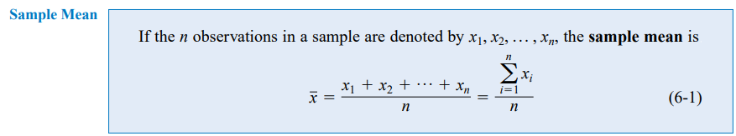

**580VN: Menu - 6 - 1 - Data - AC - OPTN - 2**

**570VN: Mode - 3 - 1 - Data - AC - Shift - 1 - 4 - 2**

**Sample Median:** is the “middle” number (50% above, 50% below).

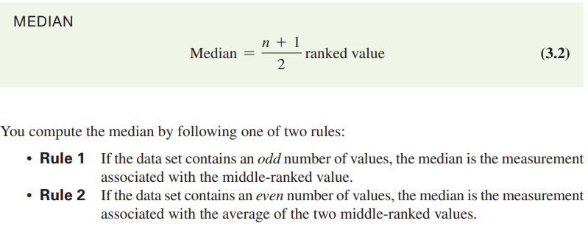

1. Rank the data set in increasing order.

2. Median position = position in the ordered data.

n: sample size

* If the number of values is odd, the median is the middle number.
* If the number of values is even, the median is the average of the two middle numbers.

**580VN: Menu - 6 - 1 - Data - AC - OPTN - 2**

**Sample Mode:**

Value that occurs most often.

There may be **no mode** OR there may be **several modes**.

**Sample Range**

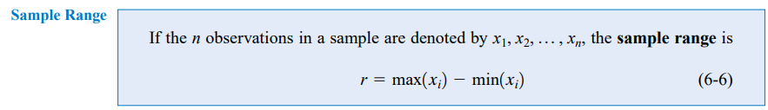

**Sample Variance:** Average (approximately) of squared deviations of values from the mean.

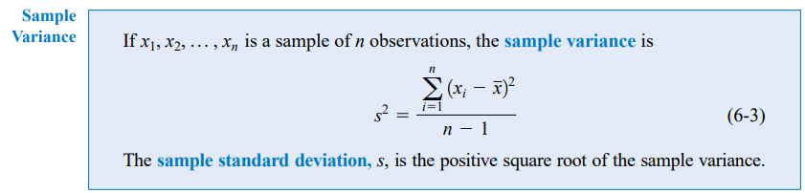

**580VN: Menu - 6 - 1 - Data - AC - OPTN - 2**

**570VN: Mode - 3 - 1 - Data - AC - Shift - 1 - 4 - 4 - ^2**

**Sample Standard Deviation:** Is the square root of the variance.

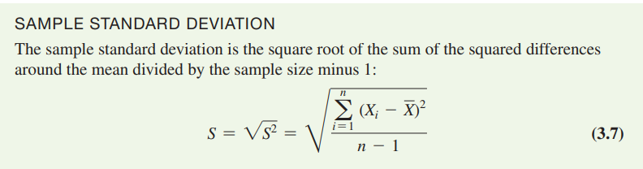

**580VN: Menu - 6 - 1 - Data - AC - OPTN - 2**

**570VN: Mode - 3 - 1 - Data - AC - Shift - 1 - 4 - 4**

1. **Numerical Descriptive Measures for a Population**

**Population Mean**

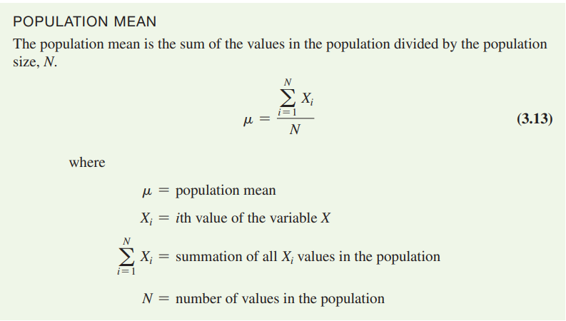

**580VN: Menu - 6 - 1 - Data - AC - OPTN - 2**

**570VN: Mode - 3 - 1 - Data - AC - Shift - 1 - 4 - 2**

**Population Variance & Population Standard Deviation**

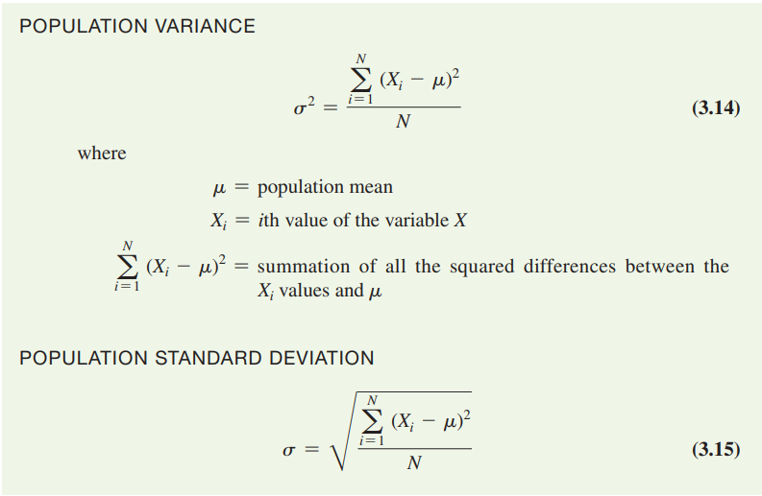

**Population Variance**

**580VN: Menu - 6 - 1 - Data - AC - OPTN - 2**

**570VN: Mode - 3 - 1 - Data - AC - Shift - 1 - 4 - 3 - ^2**

**Population Standard Deviation**

**580VN: Menu - 6 - 1 - Data - AC - OPTN - 2**

**570VN: Mode - 3 - 1 - Data - AC - Shift - 1 - 4 – 3**

1. **Chart & Diagram & Table**

**3.1 Box Plots** 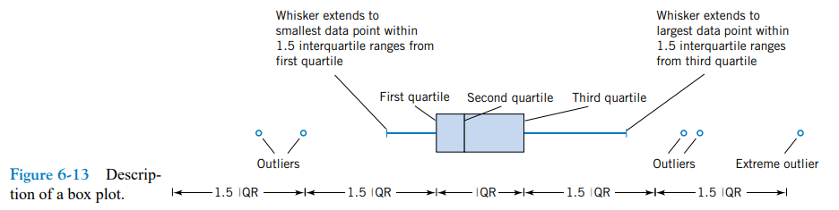

**Quartiles** split the ranked data into **4 segments** with an **equal number of values** per segment.

The first quartile, **Q1**, is the value for which 25% of the values are smaller and 75% are larger.

**Q2** is the same as the median (50% of the values are smaller and 50% are larger).

Only 25% of the values are greater than **the third quartile**.

**Find a quartile** by determining the value in the appropriate position in the ranked data, where:

First quartile position: ranked value.

Second quartile position: ranked value.

Third quartile position: ranked value.

where n is the number of observed values.

The **Interquartile Range** (**IQR**) is **Q3 – Q1** and measures the spread in the **middle 50% of the data**.

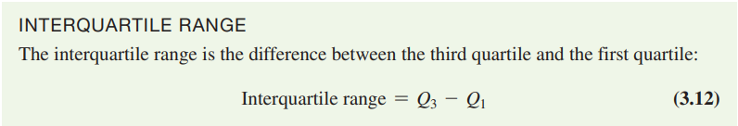

An **outlier** is an observation that is numerically distant from the rest of the data

(< Q1 - 1.5 * IQR **OR** > Q3 + 1.5 * IQR).

**3.2 Stem and leaf diagram**

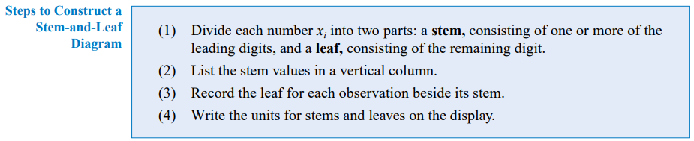

**3.3 Histogram** 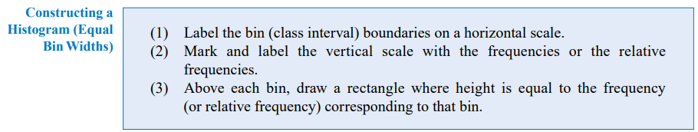

**3.4 Frequency distribution**

**n: sample size**

**class/bin**

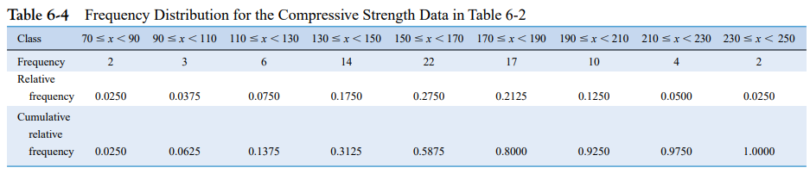

population, sample

probability distribution table → population

liệt kê → 90% sample